**Assignment 1**

**Due:** Saturday, 9 July 2022, 11:59 PM

**Done:** Make a submission

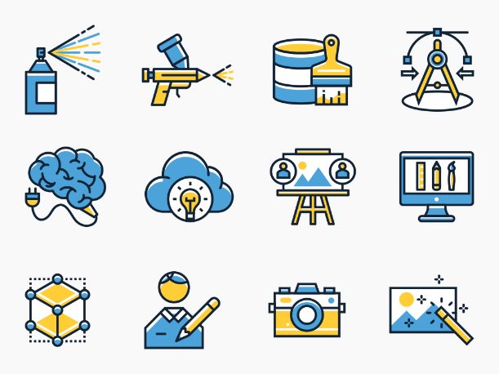

**Design inception** puts you in a position to start work on an end-to-end slice of functionality for your product – a minimum testable solution.

The design inception sheet is your first design step toward that solution in this course. This sheet is the smallest thing you can build which demonstrates the fundamental concepts of your solution and validates the end-to-end value of your proposition.

Describe your provided **inception sheet** from the inside out. Establish a strong “why” for your assigned brief and make sure the visual language relates to that “why.” What is your creative direction? Why did you choose this direction? Correlate your design decisions to research and planning. What mood are you trying to create (ex. fun, playful, serious, professional)? This sheet will help you to initiate the UI design inception process and later in the course, you will use this sheet to create a moodboard for your website.

**Identify the 4 elements of the Visual Language in your design inception:**

* **Colour**: palette inspiration, colour psychology
* **Space**: open, free, condensed
* **Shape:** rounded, hard edge, circular, boxed, curvy
* **Movement:** flowing, zig-zagged

**SoundPlay music app.**

Fill out the design inception worksheet for the design brief uploaded on eClass. Feel free to involve your friends and family members.

**You can follow the following steps to fill in your inception chart.**

**Step 1:** Ask: Why would you or someone use this app? Ask yourself or other participants to elaborate and give as many reasons as possible, by asking them “why” at least 4 to 5 times.

**Step 2:** Note any insights or keywords and identify the overall mood of the App

**Step 3:** Identify the Visual Language: Shape, Space, Movement, Colour

**Deliverables:**

Design Inception Chart

**Submission guidelines:**

1. Take photographs or scan your paper drawings, or you can simply copy-paste drawings from a drawing tool if you have used one.
2. Submit PDF or share the Google Doc link on eClass

**Evaluation Criteria:**

* **Organization and Clarity**: The layout and information display is organized, simple, efficient, and clear. Giving the design team a clear path forward when designing the app interface.
* **Design Ideas**: The 4 elements of the Visual Language are representing and establishing a powerful but relevant message (why); labels are coherent with the overall theme and design schemes
* **Human-Centered:** being able to identify the goal and mood that enhance and support what the future interface design would offer
* **Focused:** Project clearly establishes and communicates a goal, creating suggestive and explicit directional cues for conversion. Showing a thorough application of the research process and research findings